Demo instrument fitting params

# Make the fitting faster by selecting good starting parameters

Use

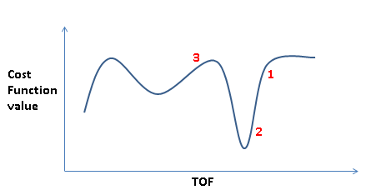

to give overview of what you want to achieve, that is, starting from 1 will take longer than starting from 2 to get to the global minimum of the displayed graph, and for a strictly local minimizer starting from 3 will not get your there at all.

Open HRP39182.raw (available as workshop.zip from download.mantidproject.org) and plot first spectrum. For example zoom in on the peak around 93150.

Then select to add a Gaussian peak. This peak will by default have sigma=0.0. It is a factory default and it cannot be clever about your data. Then alter the peak width (sigma) and explain that the fit you obtain will depend on the starting value of sigma, and, for example, end up with a sigma value as shown in figure below:

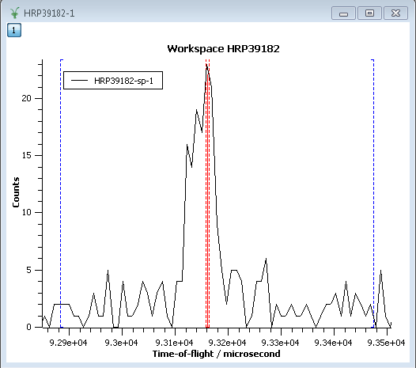

Potentially ask the audience what you would expect to happen if you did a fit at this point. Basically given no other information you would hope it would fit just that sharp feature (which for a model consisting of you just Gaussian in the fitting range is the closest local minimum from this starting point).

Do the fit and you get the result shown below (or something hopefully quite similar):

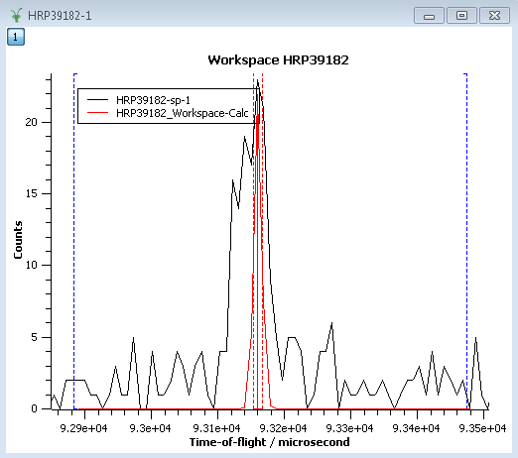

However from knowledge of the instrument, you may know that the user should just fit one peak for the entire region 93100 to 93200.

Hence in order to help users who want to fit data of an instrument, in this case HRPD, you can do something like this:

1. Open MantidInstall/instrument/HRPD_Parameters.xml
2. Add the following lines to this file

<component-link name="HRPD" >

<parameter name="Gaussian:Sigma" type="fitting">

<formula eq="20.0" result-unit="TOF" />

</parameter>

</component-link>

This shows a simple example of how to add instrument specific fit parameter information. The same file already contains a more complex example. In this example the lines of xml above tells the fitting that if a Gaussian is used to fit HRPD data then set Sigma=20 microseconds by default.

To test this works

1. Run LoadParameters algorithm on HRP39182.raw (or restart MantidPlot)
2. In Fit Function tab do Setup->Clear model and Display->Clear Fit Curves
3. Now add Gaussian peak exactly as before

What you should see is

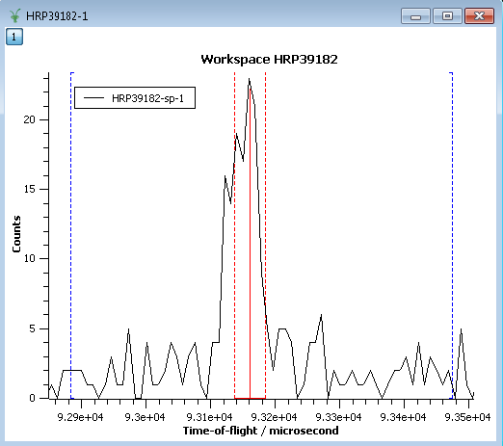

Fitting this now gives:

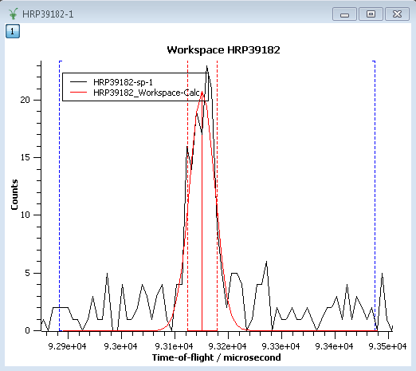

Optionally you may now plot spectrum 100 for example. Select any peak in that spectrum and fit a BackToBackExponential (the order fit function already setup in HRPD_Parameters.xml). Note before fitting you need to select a reasonable height value.